Extremely reactive to the following allergens: _________________________________________________________ THEREFORE:
□ If checked, give epinephrine immediately if the allergen was LIKELY eaten, for ANY symptoms.
□ If checked, give epinephrine immediately if the allergen was DEFINITELY eaten, even if no symptoms are apparent.
Name:
_________________________________________________________________________
D.O.B.:
____________________
Allergic to:
_________________________________________________________________________________________________
Weight:
________________
lbs.

Asthma:
□
Yes (higher risk for a severe reaction)
□
No
PLACE

PICTURE

HERE
NOTE: Do not depend on antihistamines or inhalers (bronchodilators) to treat a severe reaction.
USE EPINEPHRINE.
FOR ANY OF THE FOLLOWING:  SEVERE SYMPTOMS  LUNG HEART THROAT MOUTH  Shortness of Pale or bluish Tight or hoarse Significant breath, wheezing, skin, faintness, throat, trouble swelling of the  repetitive cough weak pulse, breathing or tongue or lips  dizziness swallowing  OR A  COMBINATION  SKIN GUT OTHER of symptoms  Many hives over Repetitive Feeling from different body, widespread vomiting, severe something bad is body areas. redness diarrhea about to happen, anxiety, confusion  - INJECT EPINEPHRINE IMMEDIATELY.  - Call 911. Tell emergency dispatcher the person is having anaphylaxis and may need epinephrine when emergency responders arrive.  - Consider giving additional medications following epinephrine:  » Antihistamine  » Inhaler (bronchodilator) if wheezing  - Lay the person flat, raise legs and keep warm. If breathing is difficult or they are vomiting, let them sit up or lie on their side.  - If symptoms do not improve, or symptoms return, more doses of epinephrine can be given about 5 minutes or more after the last dose.  - Alert emergency contacts.  - Transport patient to ER, even if symptoms resolve. Patient should remain in ER for at least 4 hours because symptoms may return. | MILD SYMPTOMS  NOSE MOUTH SKIN GUT  Itchy or Itchy mouth A few hives, Mild  runny nose, mild itch nausea or sneezing discomfort  FOR MILD SYMPTOMS FROM MORE THAN ONE SYSTEM AREA, GIVE EPINEPHRINE.  FOR MILD SYMPTOMS FROM A SINGLE SYSTEM AREA, FOLLOW THE DIRECTIONS BELOW:  - Antihistamines may be given, if ordered by a healthcare provider.  - Stay with the person; alert emergency contacts.  - Watch closely for changes. If symptoms worsen, give epinephrine.
MEDICATIONS/DOSES
Epinephrine Brand or Generic: ________________________________ Epinephrine Dose: □ 0.1 mg IM □ 0.15 mg IM □ 0.3 mg IM
Antihistamine Brand or Generic: _______________________________
Antihistamine Dose: __________________________________________
Other (e.g., inhaler-bronchodilator if wheezing): __________________
____________________________________________________________

PATIENT OR PARENT/GUARDIAN AUTHORIZATION SIGNATURE DATE PHYSICIAN/HCP AUTHORIZATION SIGNATURE DATE
FORM PROVIDED COURTESY OF FOOD ALLERGY RESEARCH & EDUCATION (FARE) (FOODALLERGY.ORG) 5/2020
HOW TO USE EPIPEN®, EPIPEN JR® (EPINEPHRINE) AUTO-INJECTOR AND EPINEPHRINE INJECTION (AUTHORIZED GENERIC OF EPIPEN®), USP AUTO-INJECTOR, MYLAN AUTO-INJECTOR, MYLAN
- Remove the EpiPen® or EpiPen Jr® Auto-Injector from the clear carrier tube.
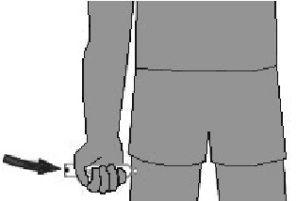
- Grasp the auto-injector in your fist with the orange tip (needle end) pointing downward. With your other hand, remove the blue safety release by pulling straight up.
4
- Swing and push the auto-injector firmly into the middle of the outer thigh until it ‘clicks’. Hold firmly in place for 3 seconds (count slowly 1, 2, 3).
- Remove and massage the injection area for 10 seconds. Call 911 and get emergency medical help right away.
HOW TO USE IMPAX EPINEPHRINE INJECTION (AUTHORIZED GENERIC OF ADRENACLICK®), USP AUTO-INJECTOR, AMNEAL PHARMACEUTICALS
- Remove epinephrine auto-injector from its protective carrying case.
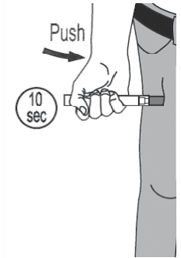
- Pull off both blue end caps: you will now see a red tip. Grasp the auto-injector in your fist with the red tip pointing downward.
5
- Put the red tip against the middle of the outer thigh at a 90-degree angle, perpendicular to the thigh. Press down hard and hold firmly against the thigh for approximately 10 seconds.
- Remove and massage the area for 10 seconds. Call 911 and get emergency medical help right away.
HOW TO USE TEVA’S GENERIC EPIPEN® (EPINEPHRINE INJECTION, USP) AUTO-INJECTOR, TEVA PHARMACEUTICAL INDUSTRIES  - Quickly twist the yellow or green cap off of the auto-injector in the direction of the “twist arrow” to remove it.  - Grasp the auto-injector in your fist with the orange tip (needle end) pointing downward. With your other hand, pull off the blue safety release.  - Place the orange tip against the middle of the outer thigh at a right angle to the thigh.  - Swing and push the auto-injector firmly into the middle of the outer thigh until it ‘clicks’. Hold firmly in place for 3 seconds (count slowly 1, 2, 3).  - Remove and massage the injection area for 10 seconds. Call 911 and get emergency medical help right away. | 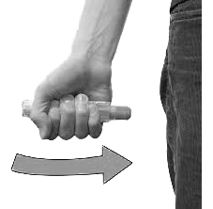  5
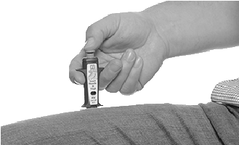
HOW TO USE SYMJEPI™ (EPINEPHRINE INJECTION, USP)
2
- When ready to inject, pull off cap to expose needle. Do not put finger on top of the device.
- Hold SYMJEPI by finger grips only and slowly insert the needle into the thigh. SYMJEPI can be injected through clothing if necessary.
- After needle is in thigh, push the plunger all the way down until it clicks and hold for 2 seconds.
- Remove the syringe and massage the injection area for 10 seconds. Call 911 and get emergency medical help right away.
- Once the injection has been administered, using one hand with fingers behind the needle slide safety guard over needle.
ADMINISTRATION AND SAFETY INFORMATION FOR ALL AUTO-INJECTORS:
- Do not put your thumb, fingers or hand over the tip of the auto-injector or inject into any body part other than mid-outer thigh. In case of accidental injection, go immediately to the nearest emergency room.
- If administering to a young child, hold their leg firmly in place before and during injection to prevent injuries.
- Epinephrine can be injected through clothing if needed.
- Call 911 immediately after injection.
HOW TO USE AUVI-Q® (EPINEPHRINE INJECTION, USP), KALEO  - Remove Auvi-Q from the outer case. Pull off red safety guard.  - Place black end of Auvi-Q against the middle of the outer thigh.  - Press firmly until you hear a click and hiss sound, and hold in place for 2 seconds.  - Call 911 and get emergency medical help right away. | 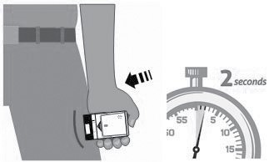  3
OTHER DIRECTIONS/INFORMATION (may self-carry epinephrine, may self-administer epinephrine, etc.):
Treat the person before calling emergency contacts. The first signs of a reaction can be mild, but symptoms can worsen quickly.
EMERGENCY CONTACTS — CALL 911  RESCUE SQUAD: ______________________________________________________________________  DOCTOR: _________________________________________________ PHONE: ____________________  PARENT/GUARDIAN: ______________________________________ PHONE: ____________________ | OTHER EMERGENCY CONTACTS  NAME/RELATIONSHIP:_____________________________________ PHONE: ____________________  NAME/RELATIONSHIP:_____________________________________ PHONE: ____________________  NAME/RELATIONSHIP:_____________________________________ PHONE: ____________________
FORM PROVIDED COURTESY OF FOOD ALLERGY RESEARCH & EDUCATION (FARE) (FOODALLERGY.ORG) 5/2020

